Data Warehousing and Business Intelligence

Assignment 02

Data Source for the Assignment

This is a hospital management system based on Data warehouse, it has four Dimensions tables and a Fact table. The fact table quantifies the billing of patients. Below Entity Relational diagram shows how they interact with each other

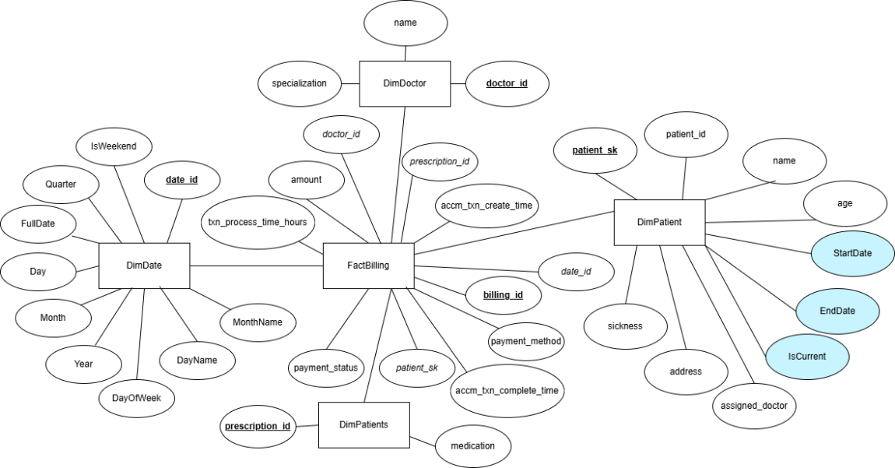

SSAS Cube Implementation

First in Visual Studio I created an Analysis and Multidimensional Project name HelathCareCube

in Data Sources of the project, pointed it to the Data Warehouse  
  
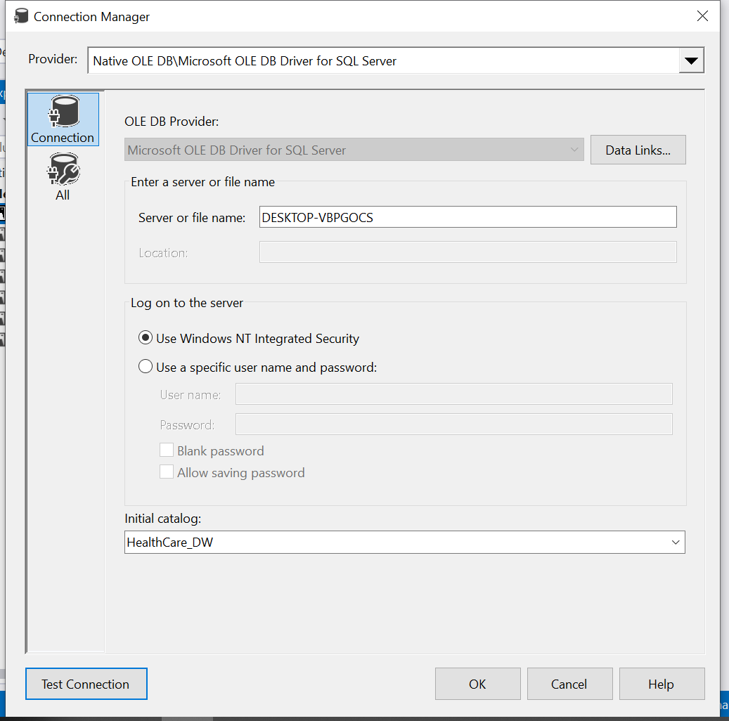  
  
Next in Data Source view, added all the tables from the Warehouse Database  
  
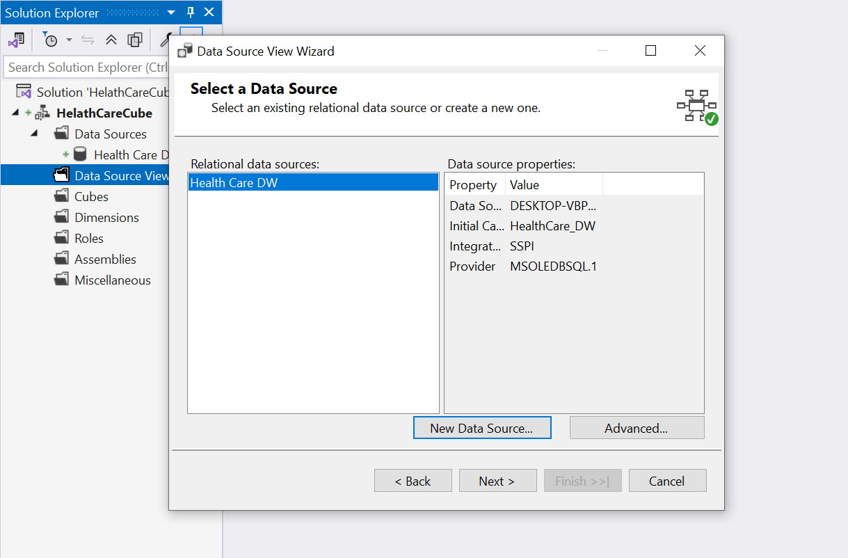  
  
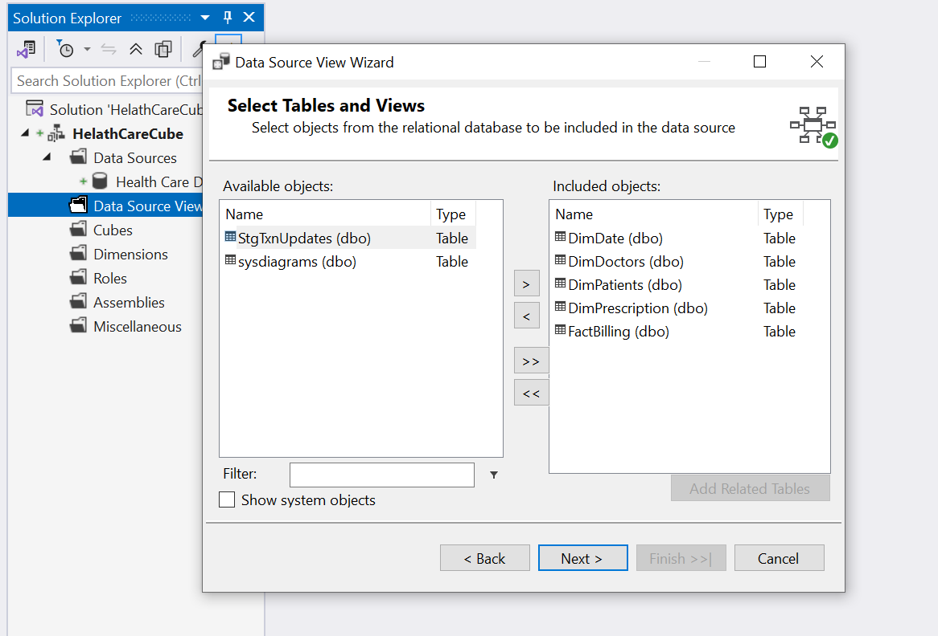  
  
Then created dimensions from the tables  
  
Did the necessary changes  
  
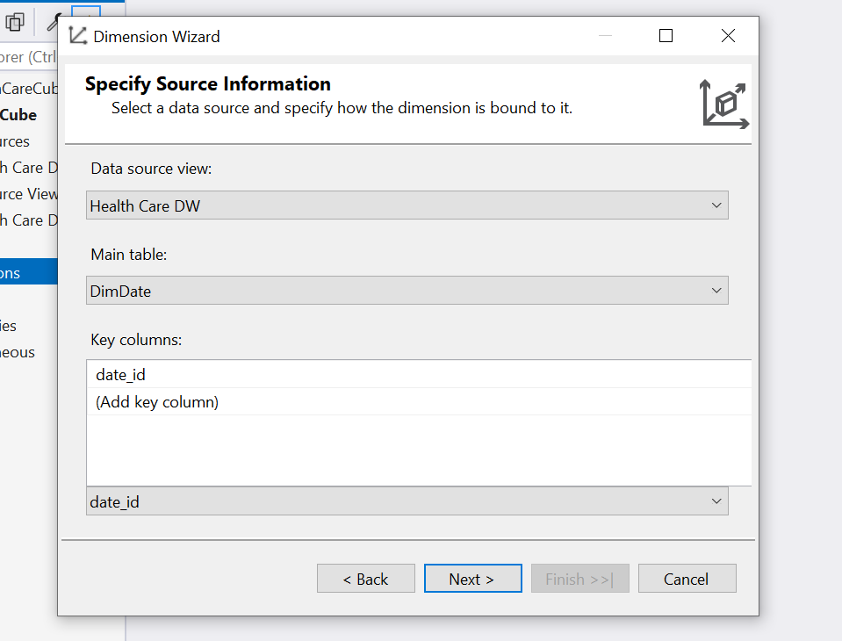  
  
Selected all in DimDate  
  
selected full date as showing values  
then selected all  
  
  
Selected all in DimDoctors  
  
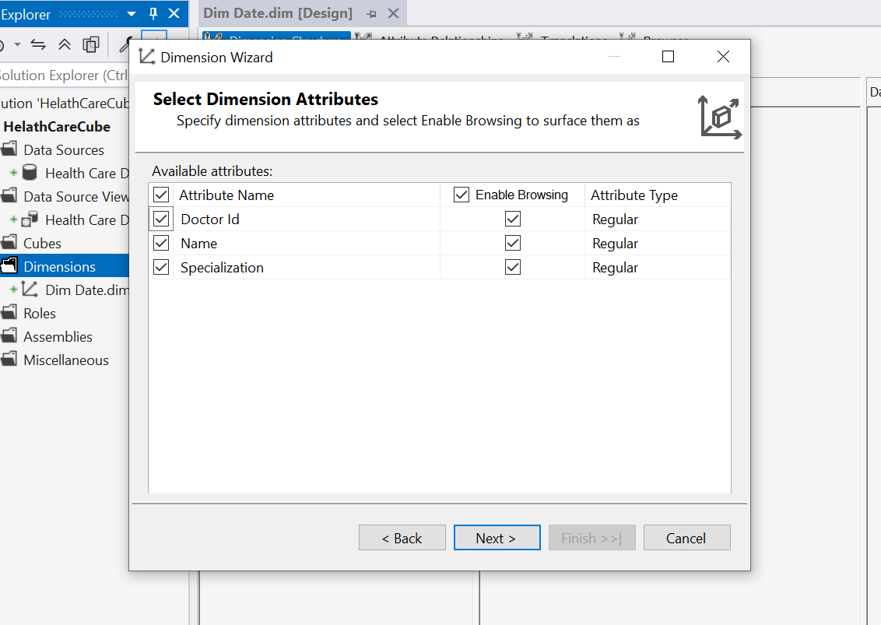

All in DimPrescription  
  
Selected all for DimPatients  
  
Then built a user hierarchy for year => Quarter => Month  
  
had to configure attribute relationships  
  
Final  
  
removed alphabetical order from month Name  
  
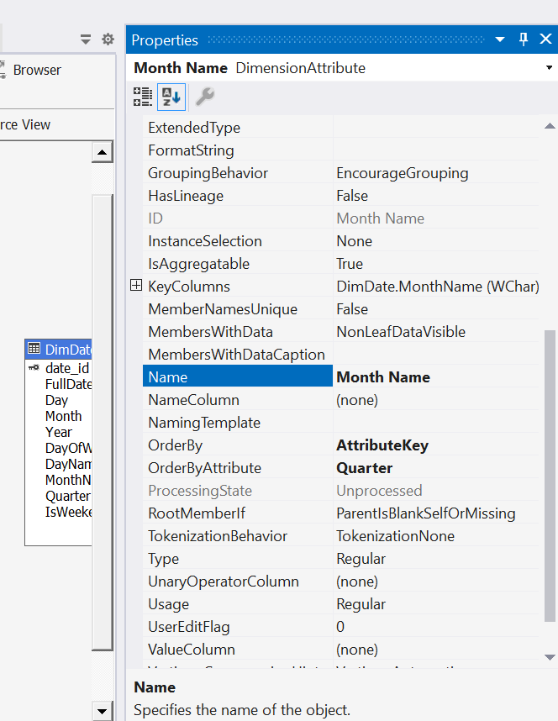  
  
  
Final as this  
  
Then started defining the cube  
  
  
select fact table and measures  
  
Final window after selecting dimensions to this  
  
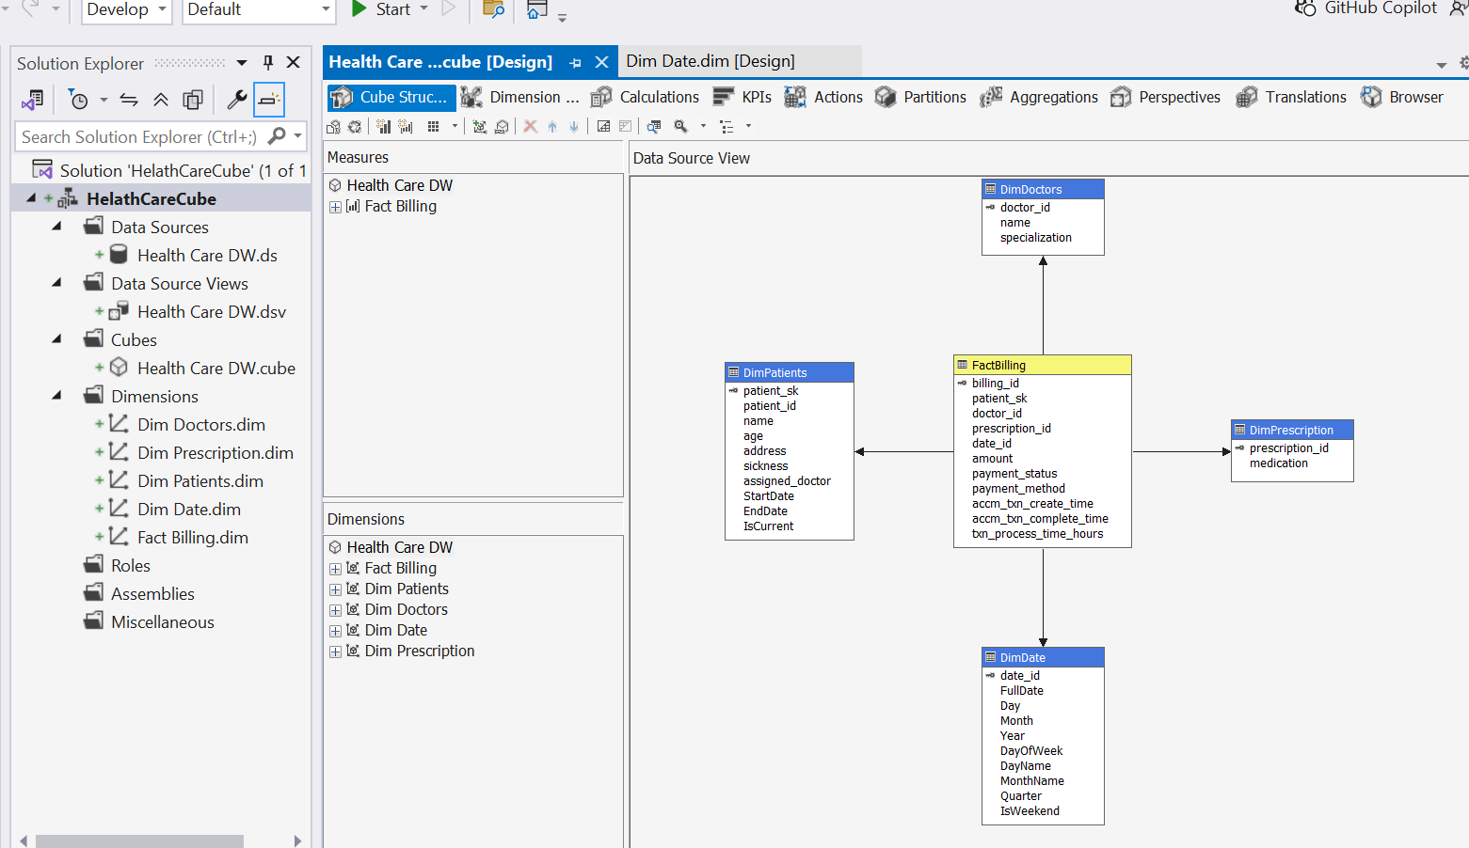  
  
Checked the dimensions usage  
  
Configured deployment properties  
  
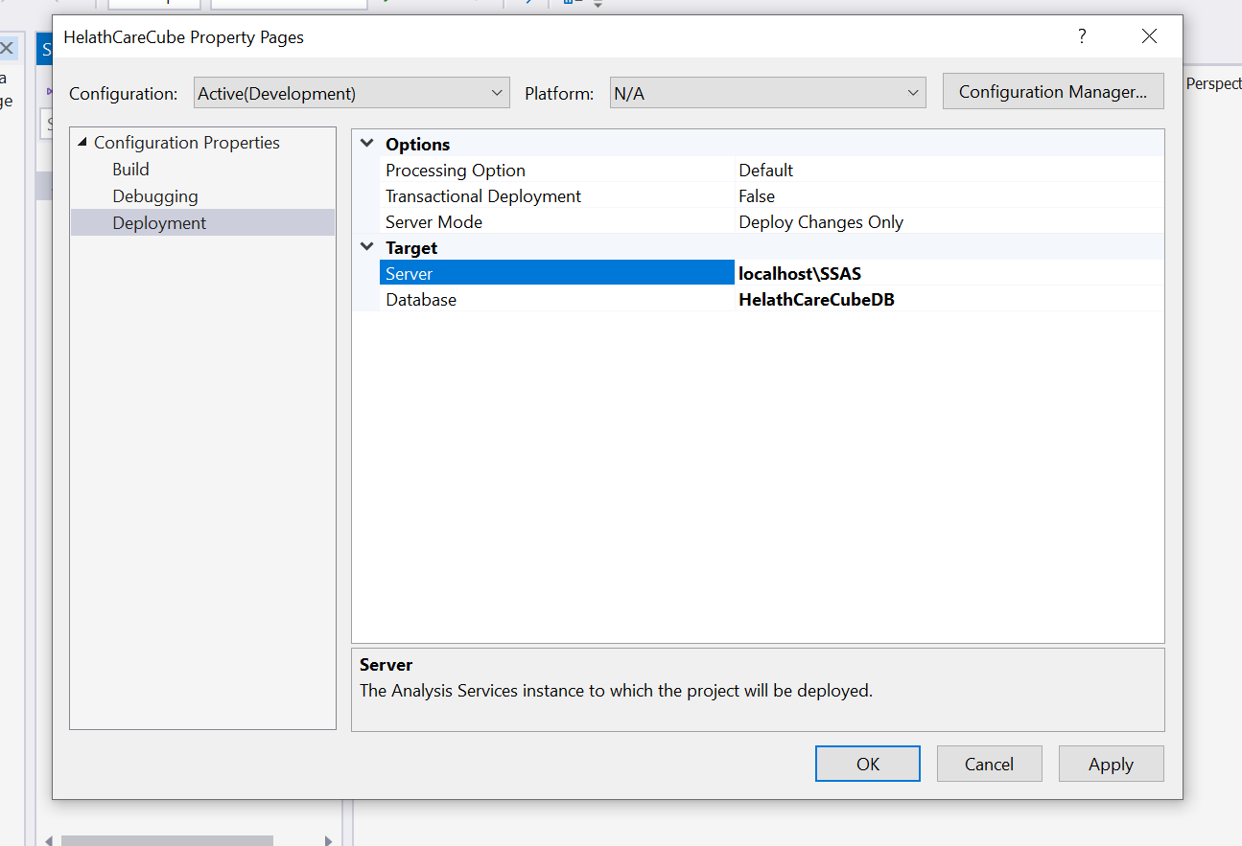  
  
Then Debugged  
There was no SQL Analysis Service, So I had to install it and run again.  
  
Configured SSAS Permissions to  
  
  
error occurred due to duplicating quarter values  
  
so set it to take year too  
  
same for month_name  
  
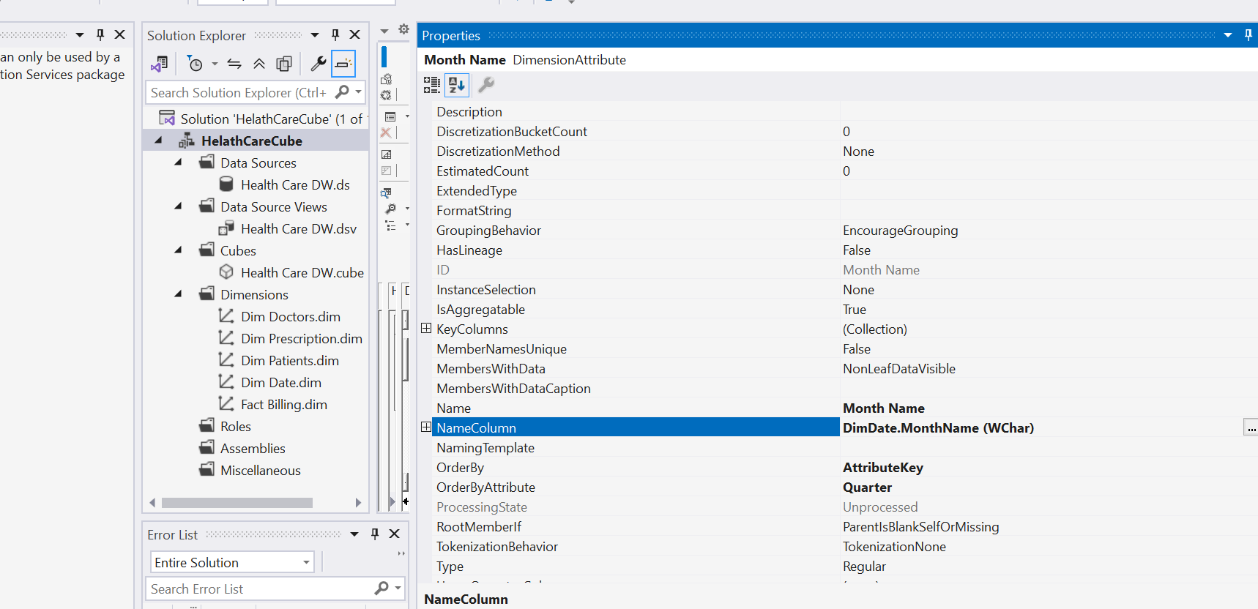  
  
then the deployment completed successfully  
  
Demonstration of OLAP operations

Opened a blank Excel file   
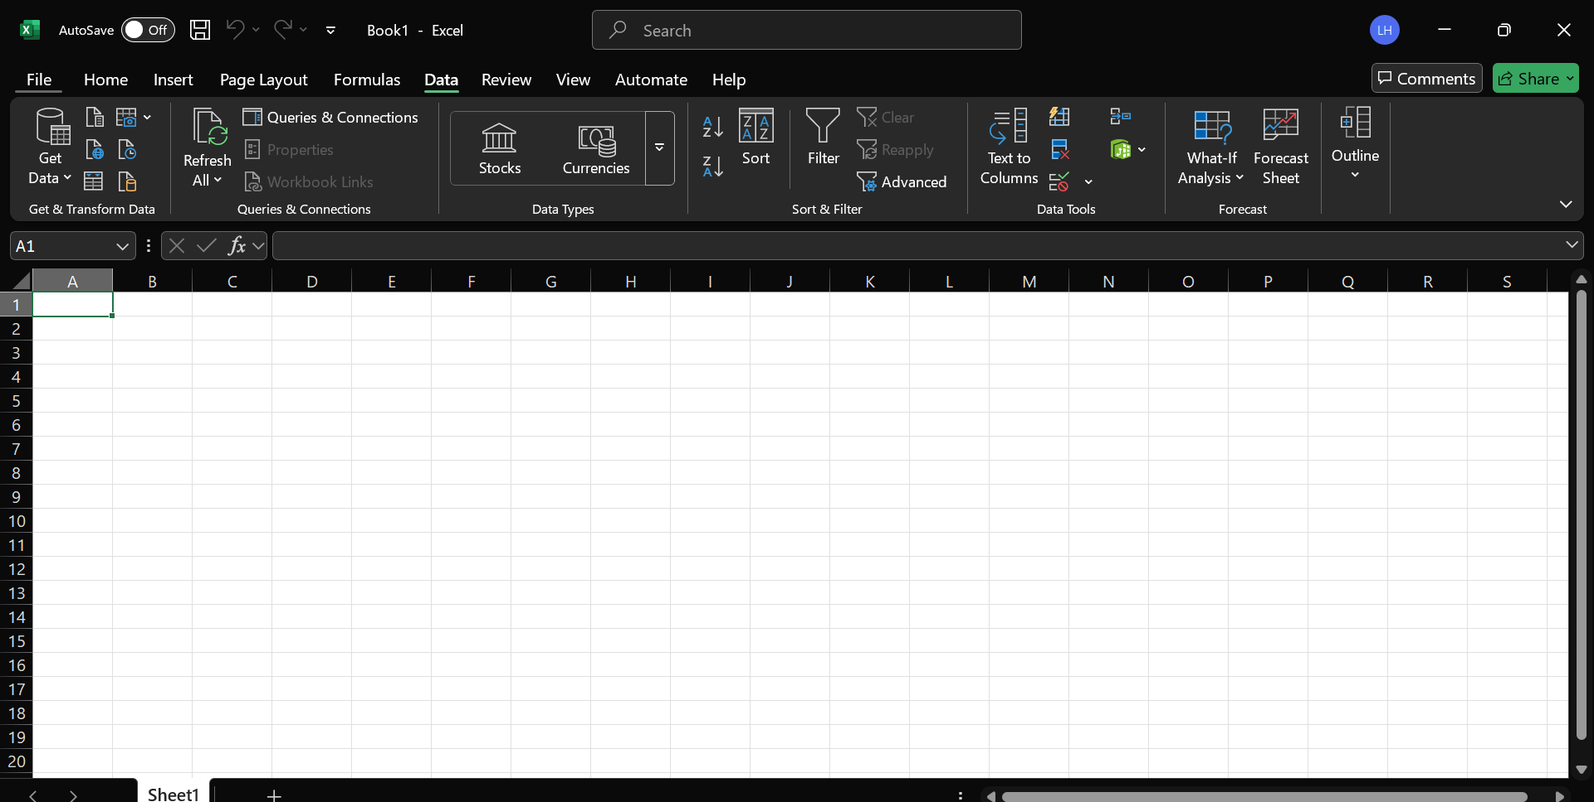  
  
In Data tab, Get Data function to get data from created SSAS HealthCareCube

Entered relevant data in here  
  
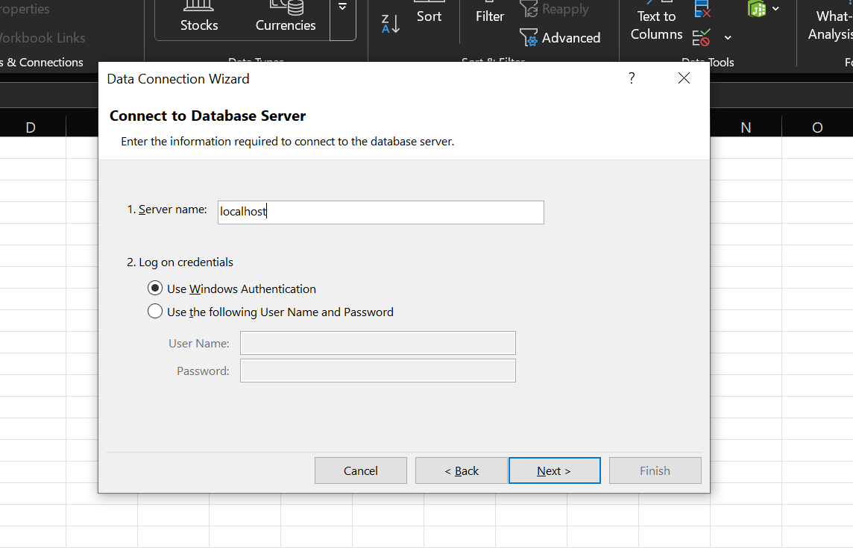  
  
Selected from the Cube  
  
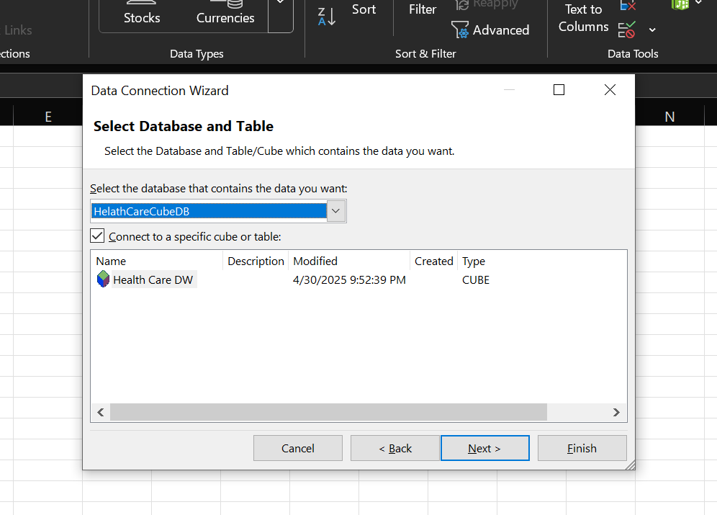  
  
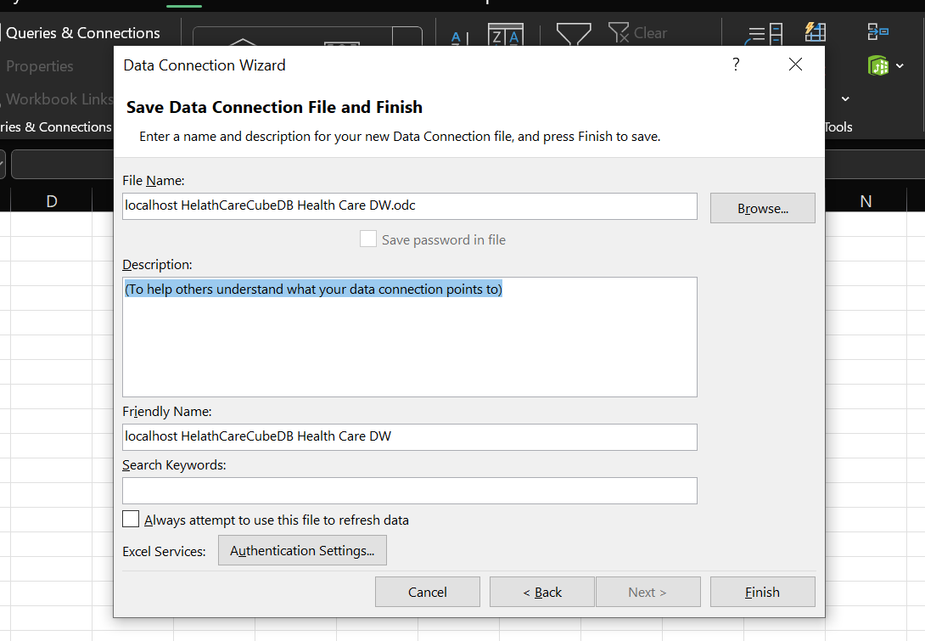  
  
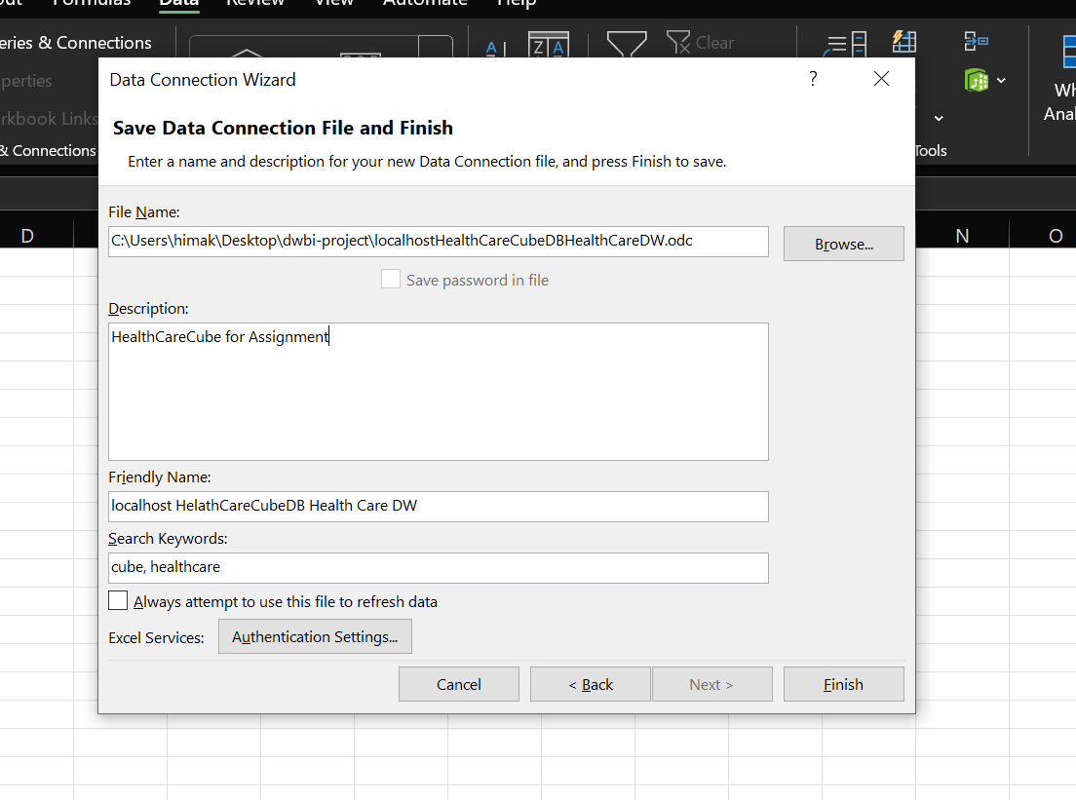  
  
Then Clicked finish  
Selected Pivot table from here   
  
Then It came a window like this  
  
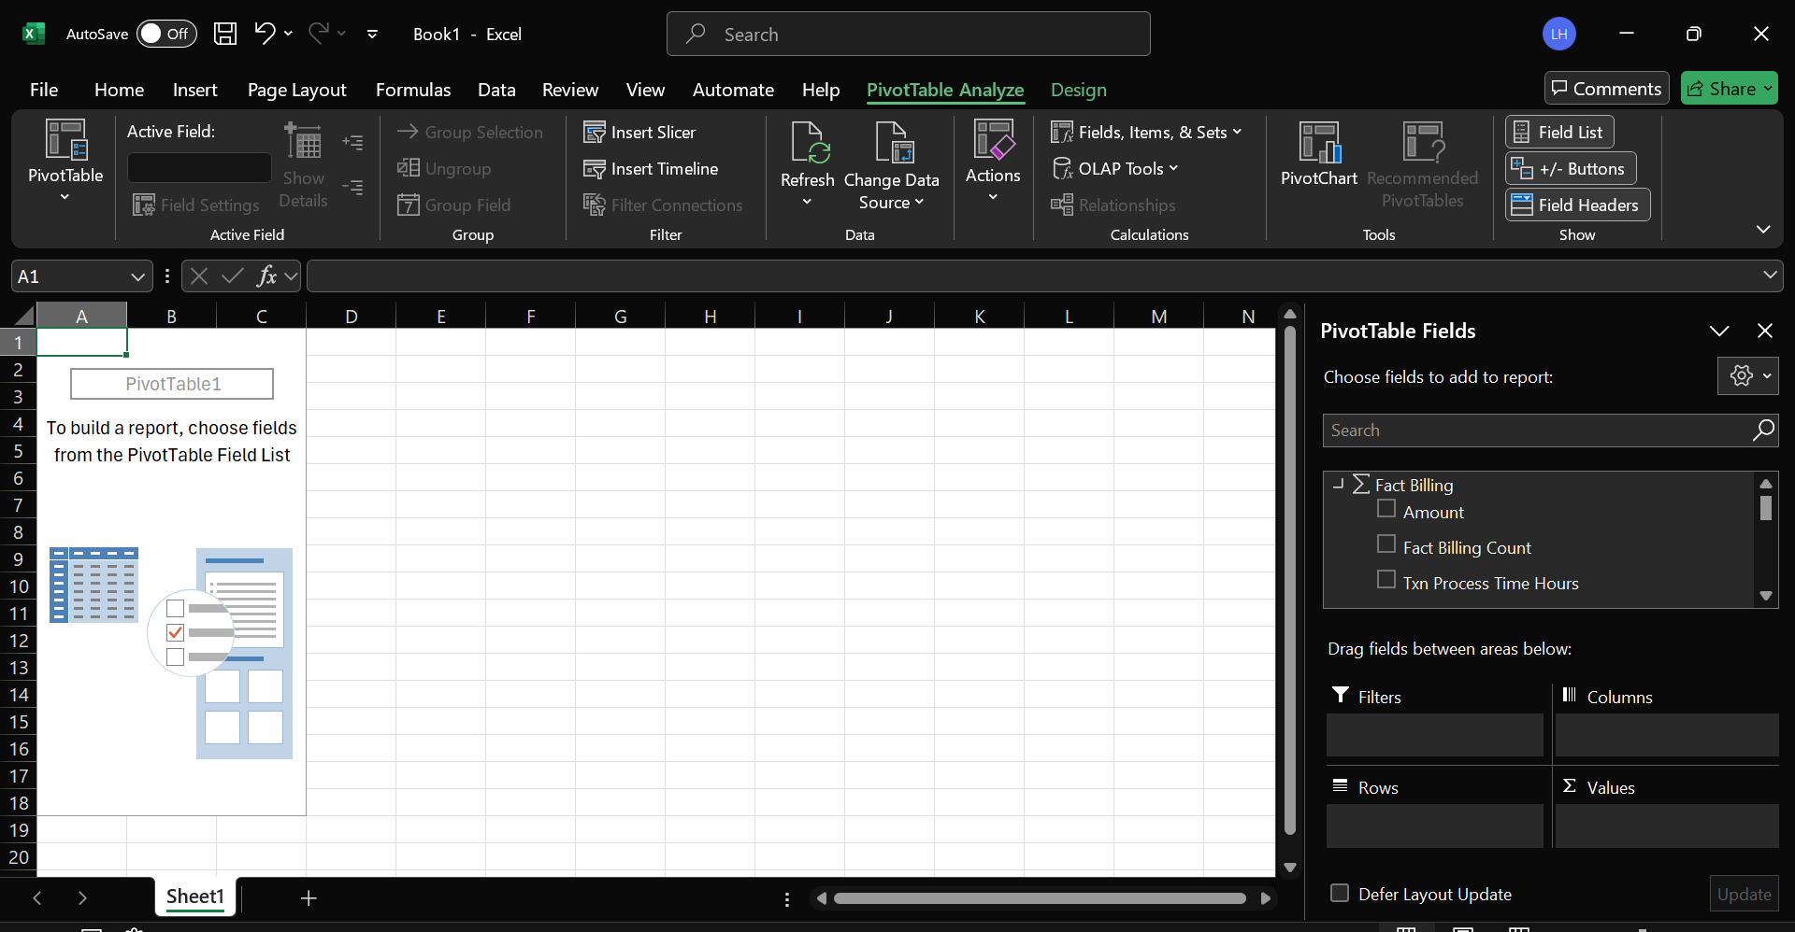  
  
Demonstration of OLAP operations  
  
Roll-Up  
  
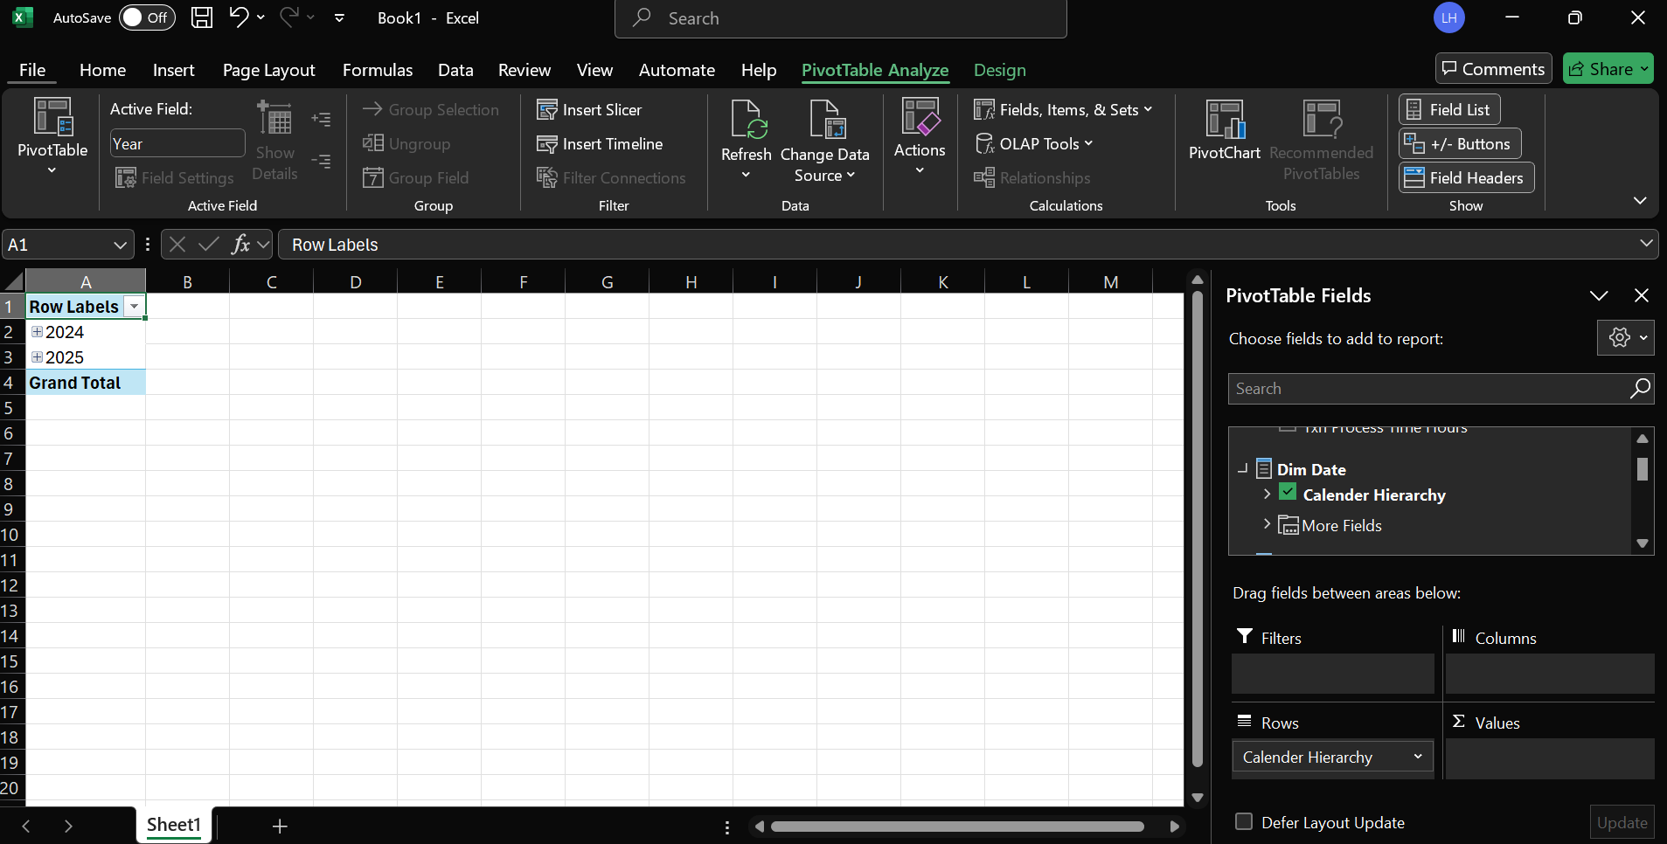  
  
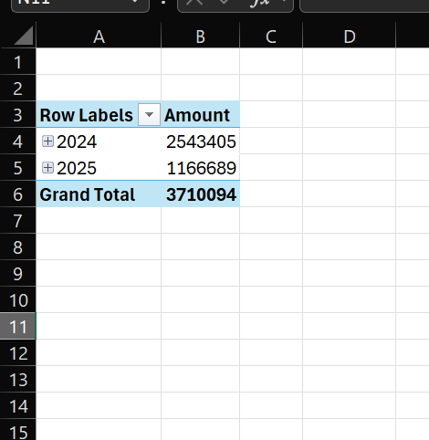  
  
  
Drill-Down  
  
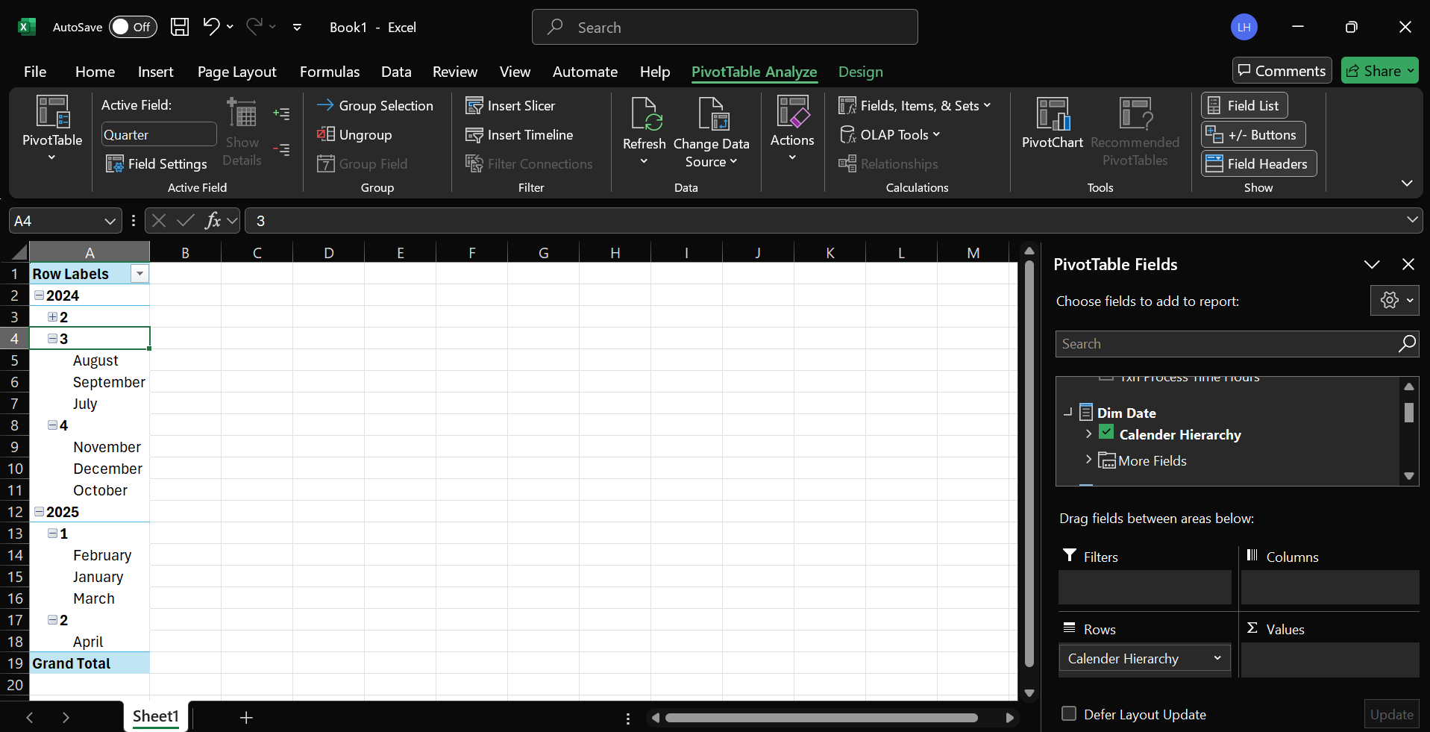  
  
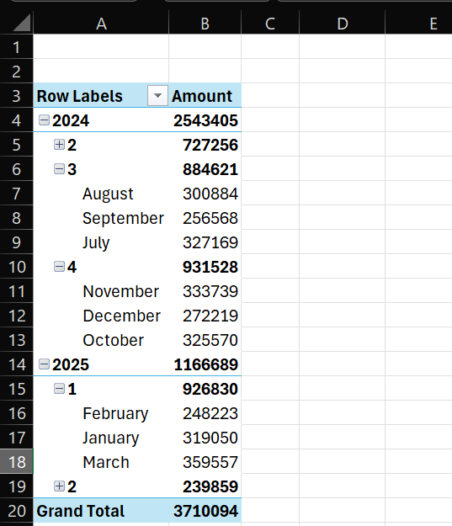  
  
Inserted a Slicer to demonstrate slice  
  
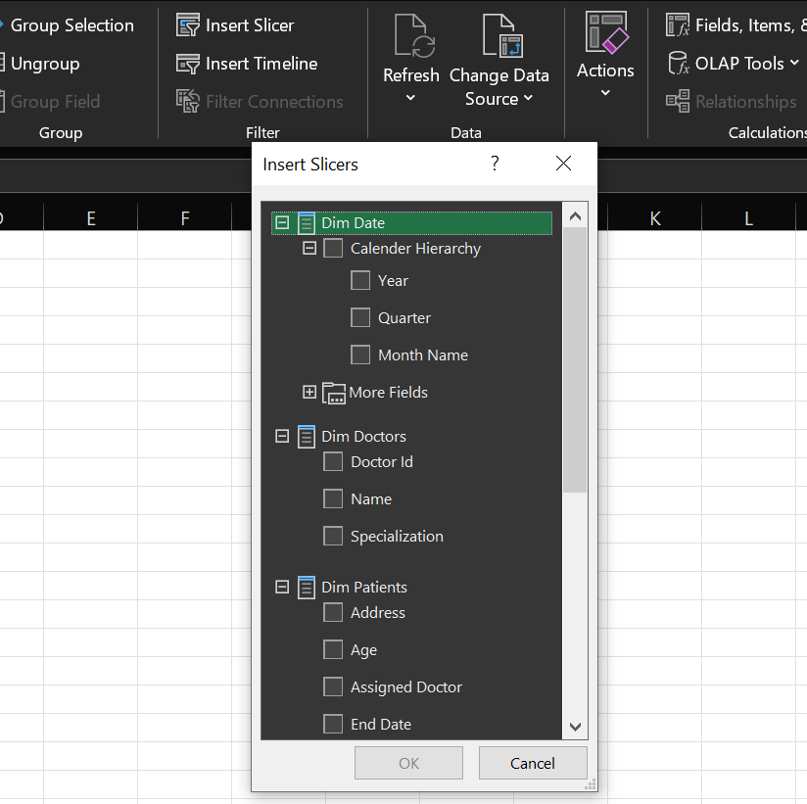  
  
Filtering out to the Doctor name  
  
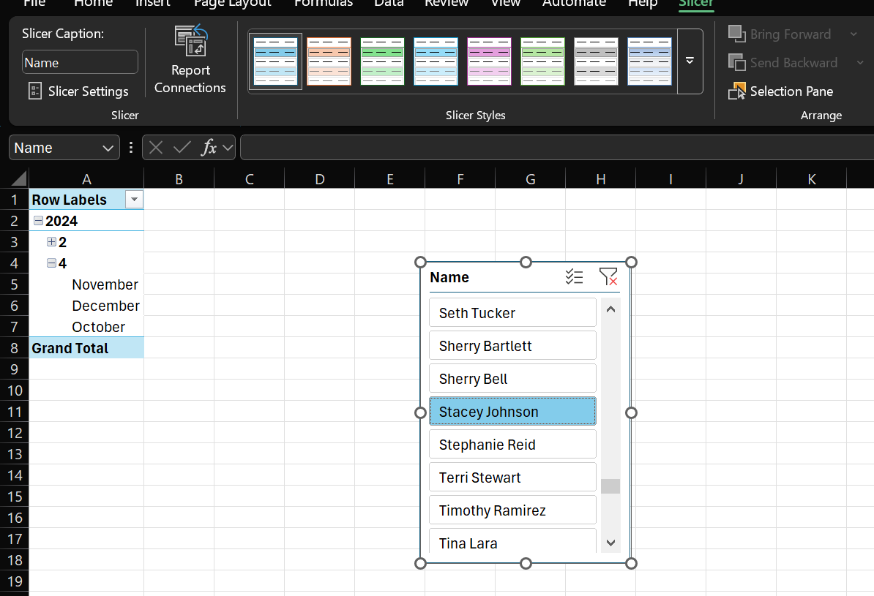  
  
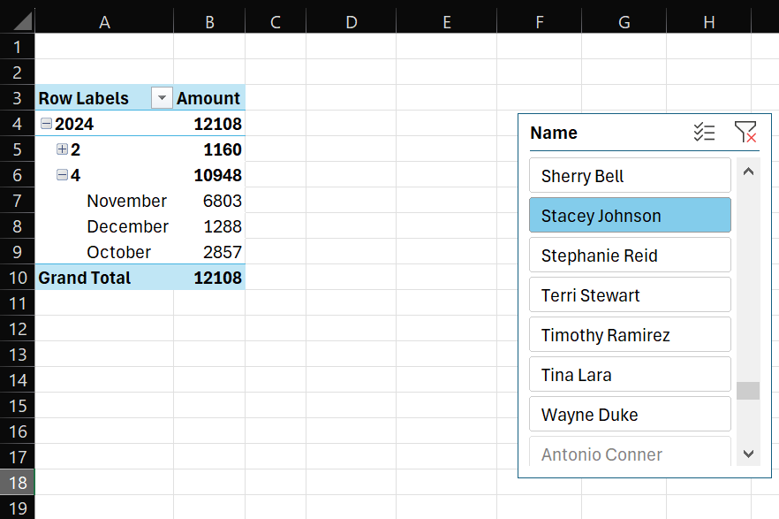  
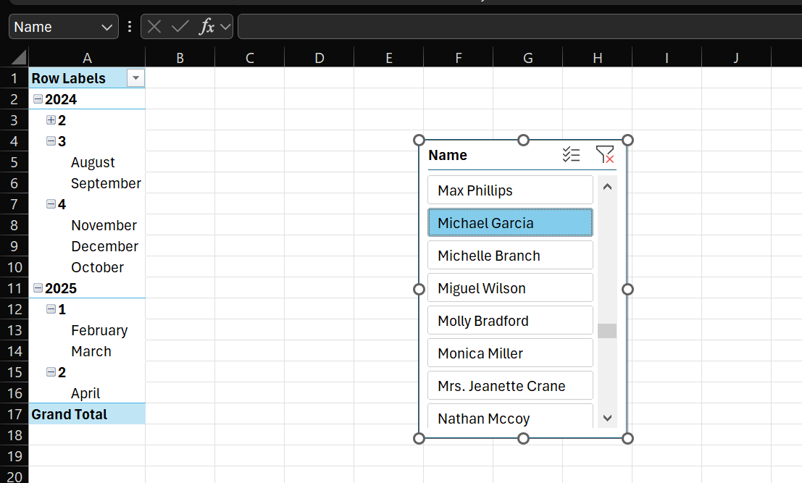  
  
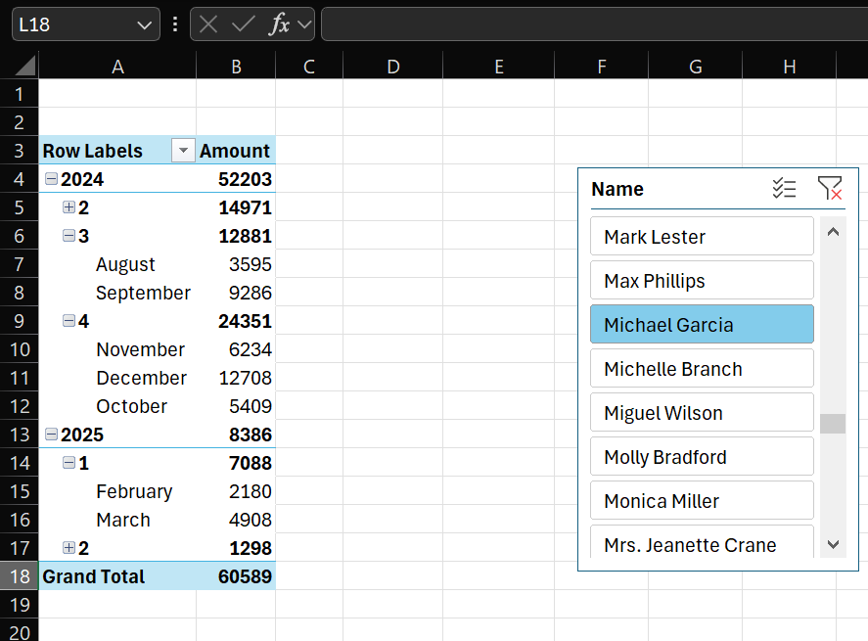  
  
  
  
  
Dicing  
  
Filtering out to multiple dimensions  
  
  
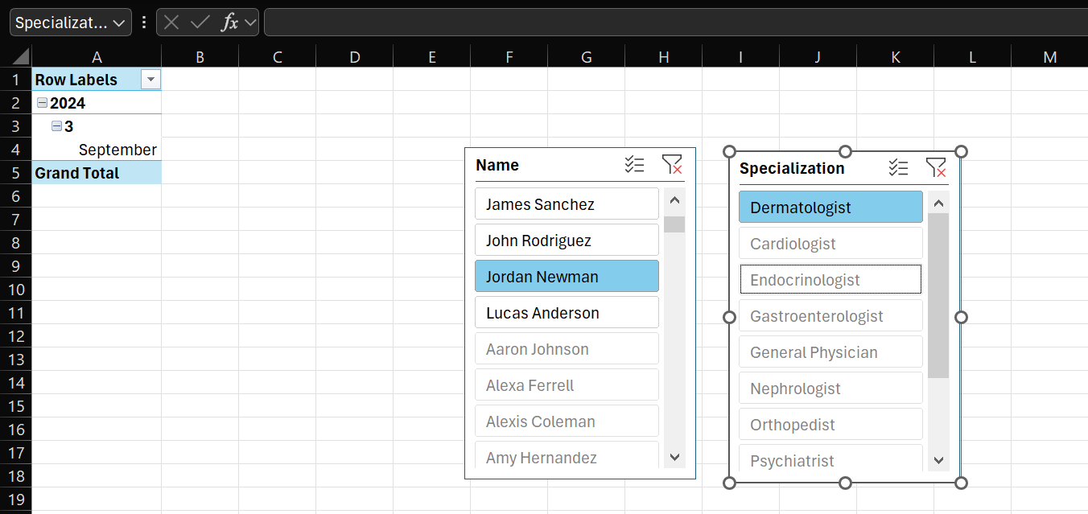  
  
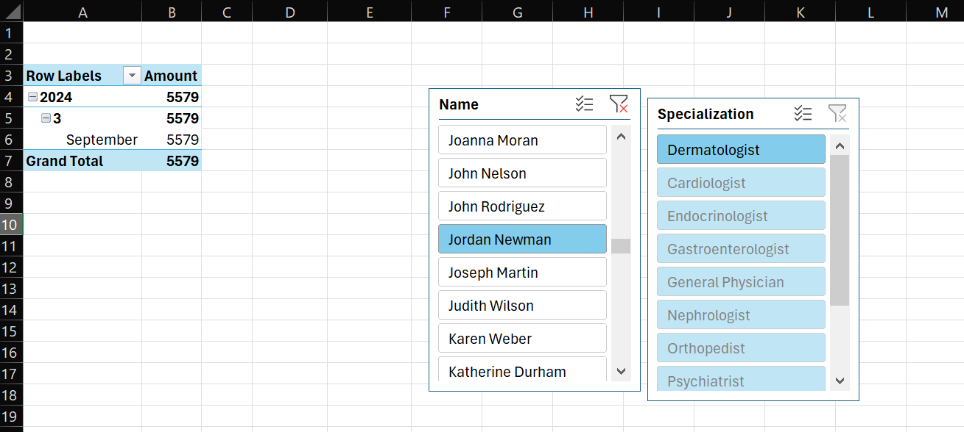  
  
Pivoting – Changing perspective of analysis  
  
Calendar hierarchy from Rows to Columns  
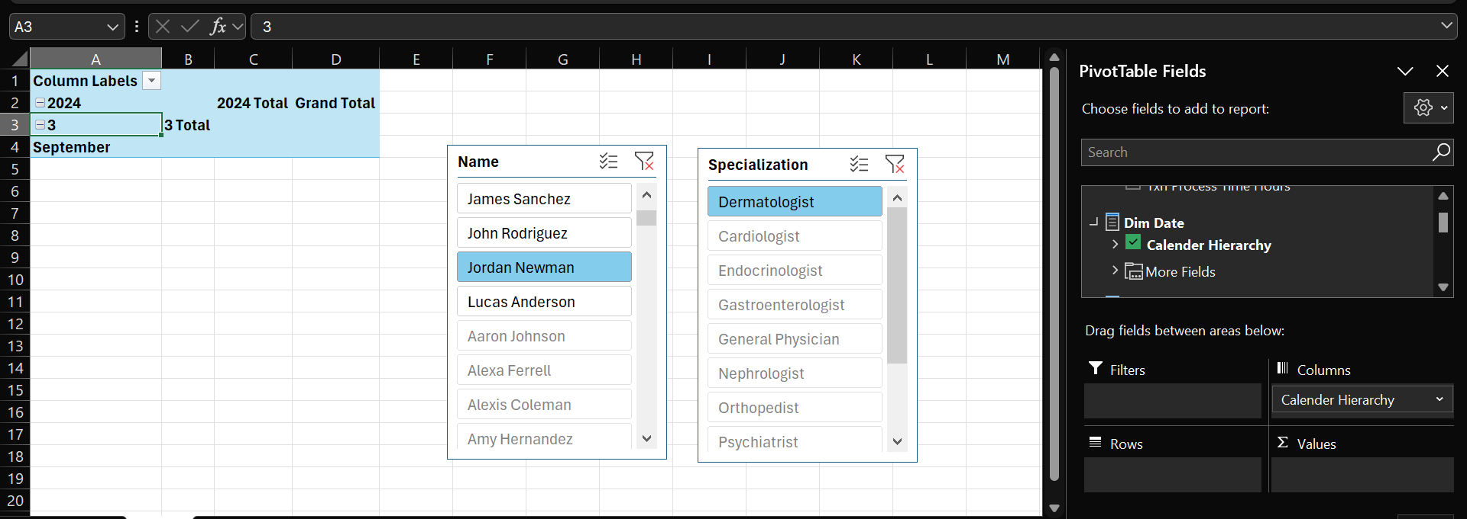  
  
  
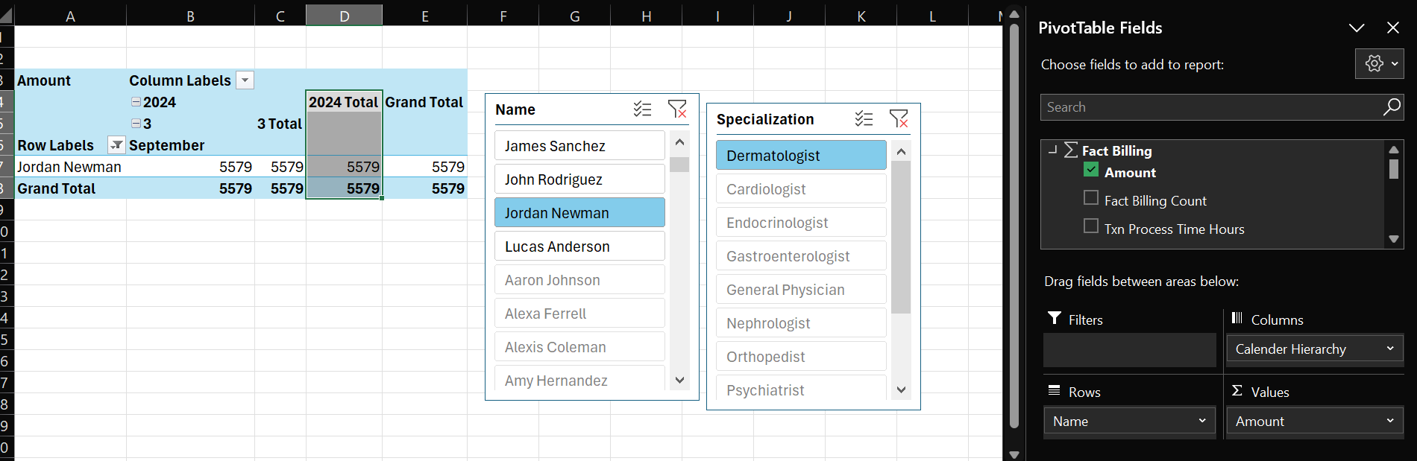

Power BI Reports  
  
Getting Data from my HealthCareCube here  
  
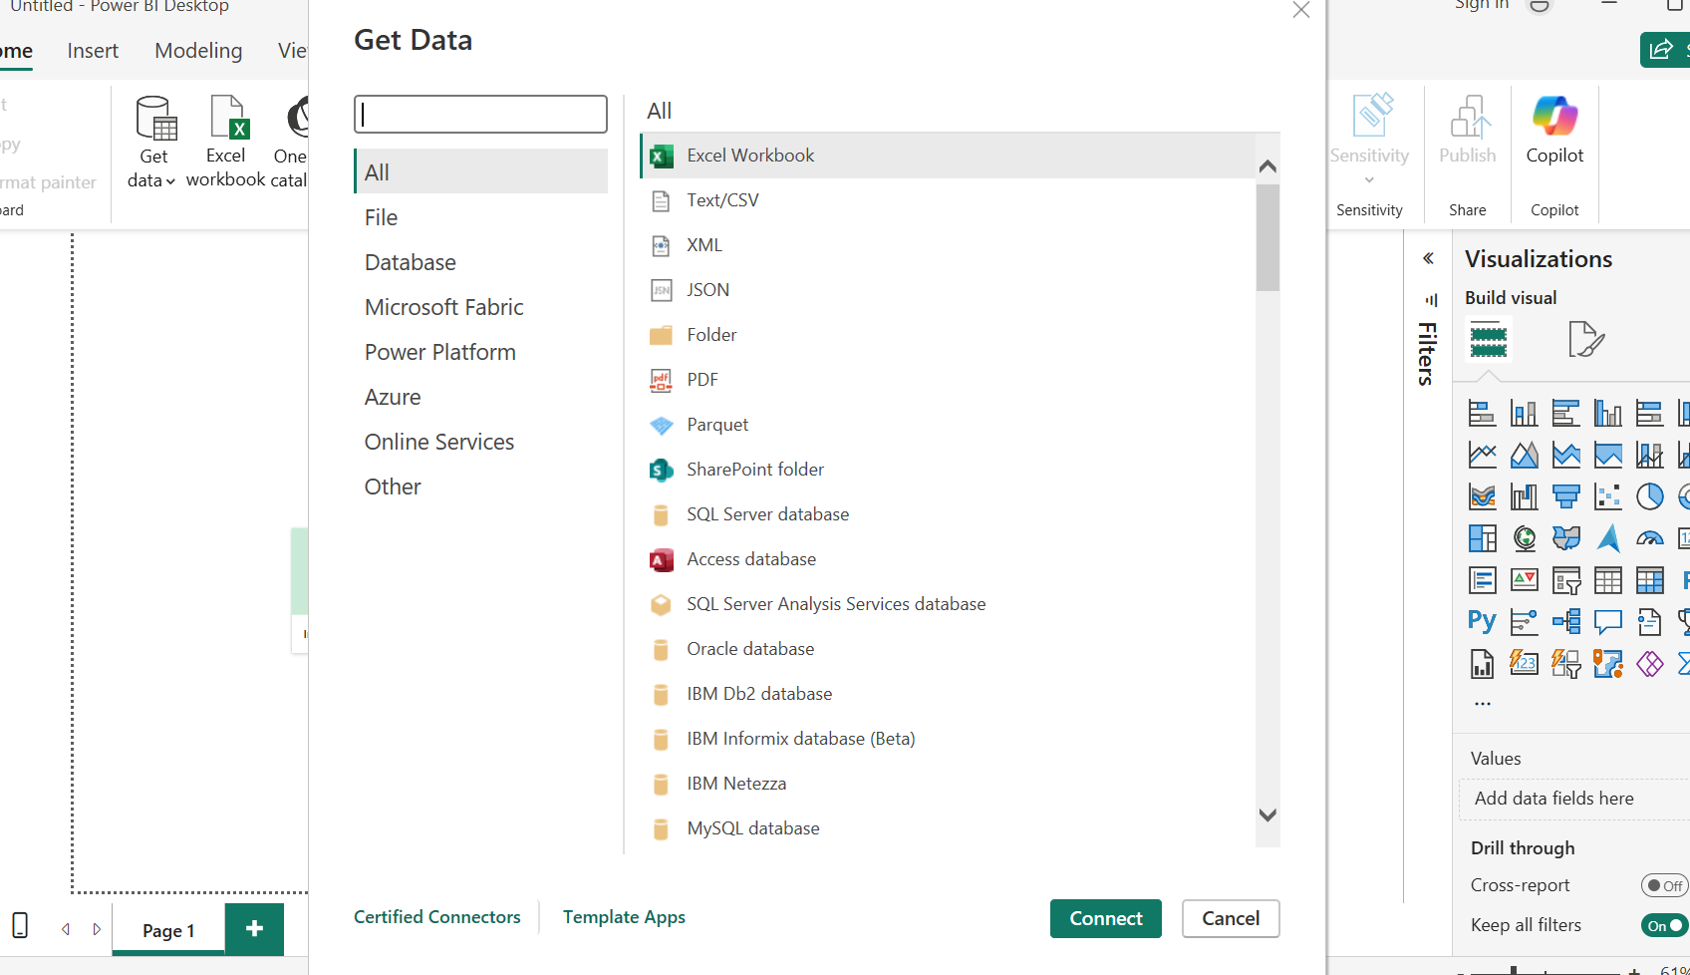  
  
Filled necessary data  
  
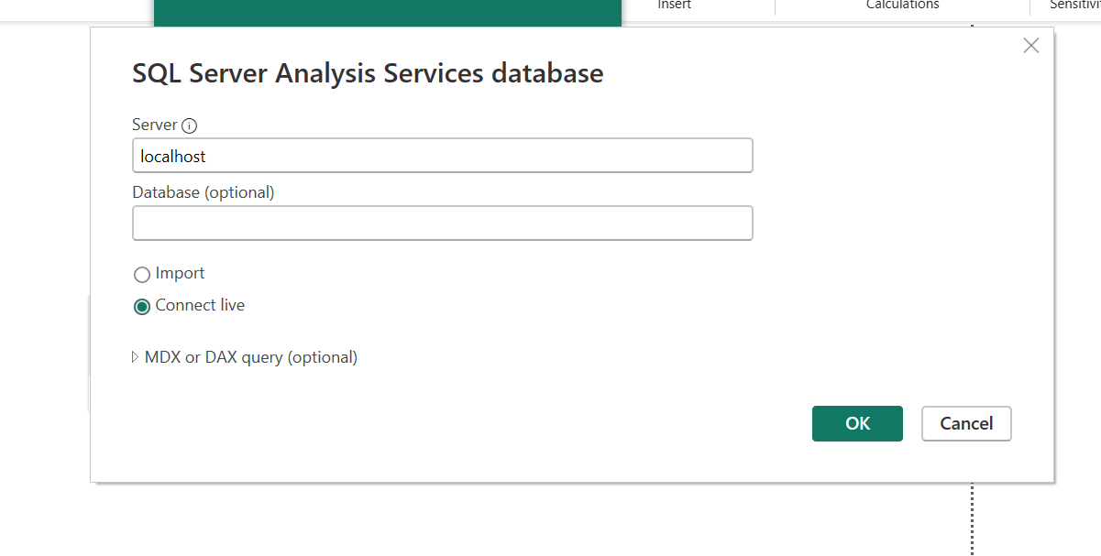  
  
It loaded as this  
  
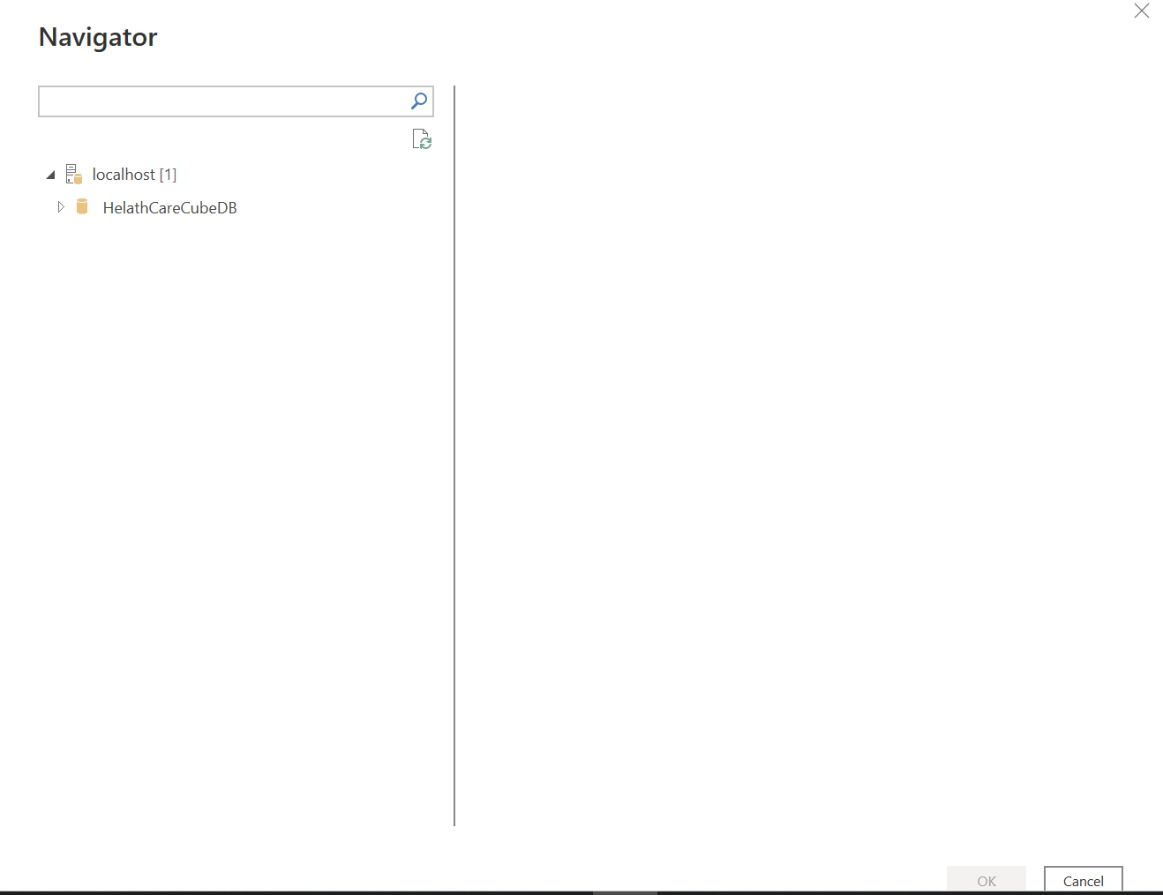  
  
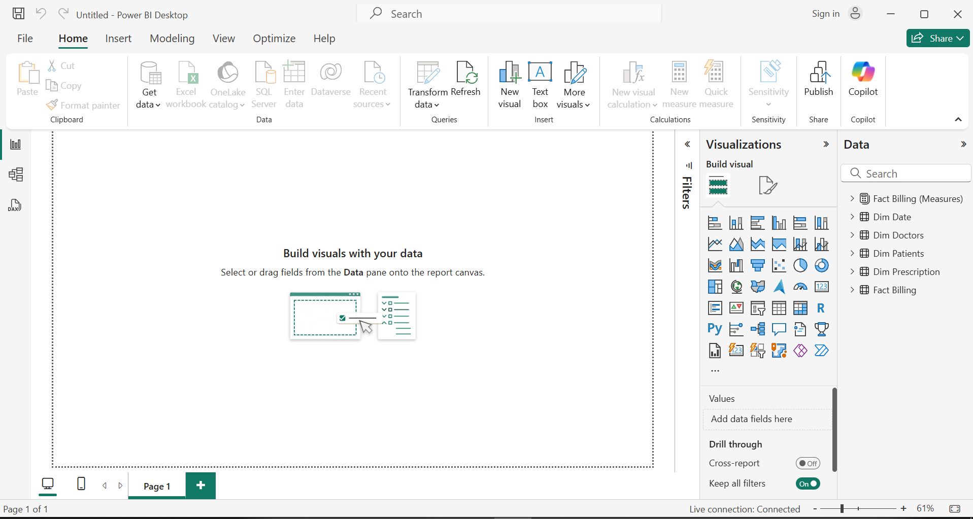  
  
Matrix visual to display detailed tabular data with row and column groupings  
  
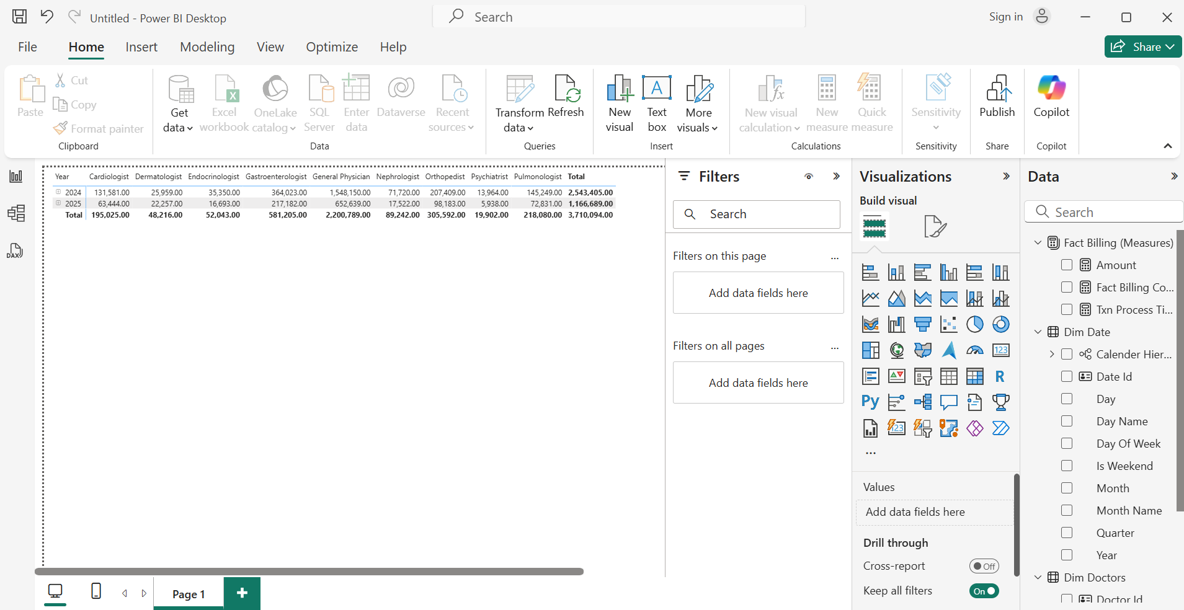  
  
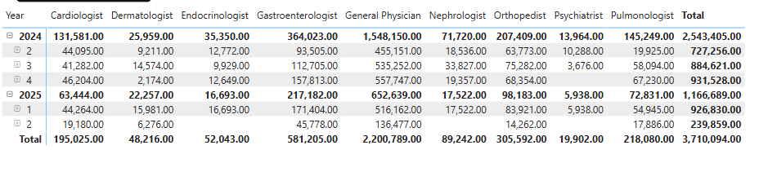  
  
Report 2  
  
Cascading filters with Bar chart and a Pie chart  
  
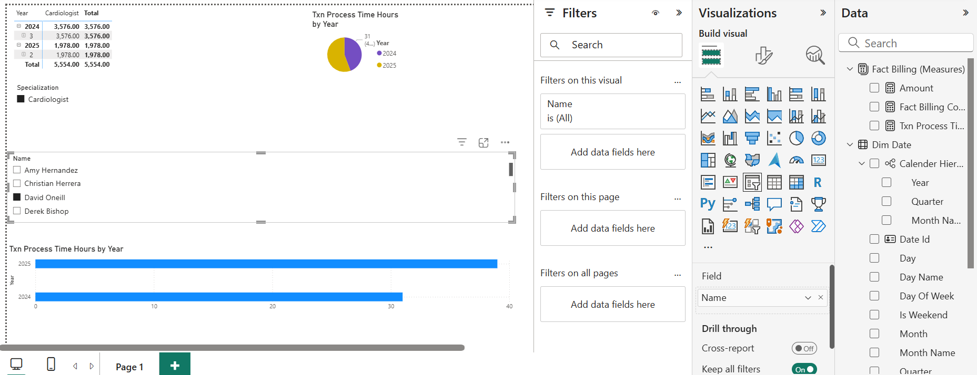  
  
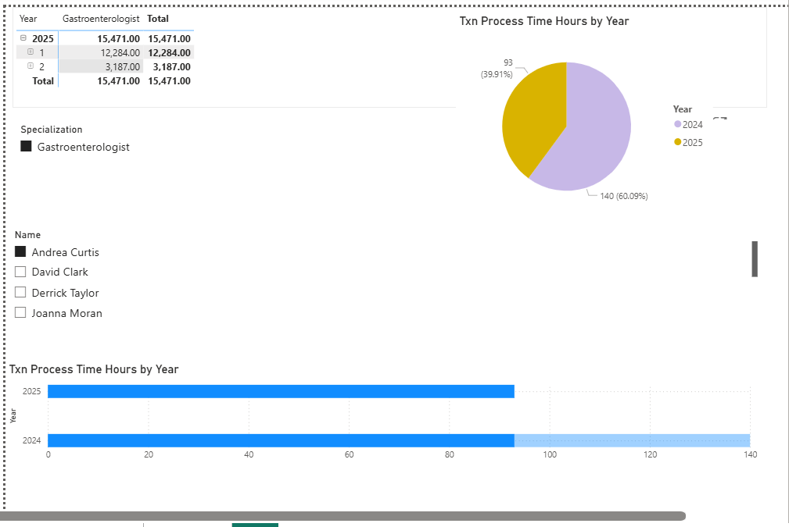  
  
Report 3  
  
Drill Down Report  
  
Drill Down chart  
  
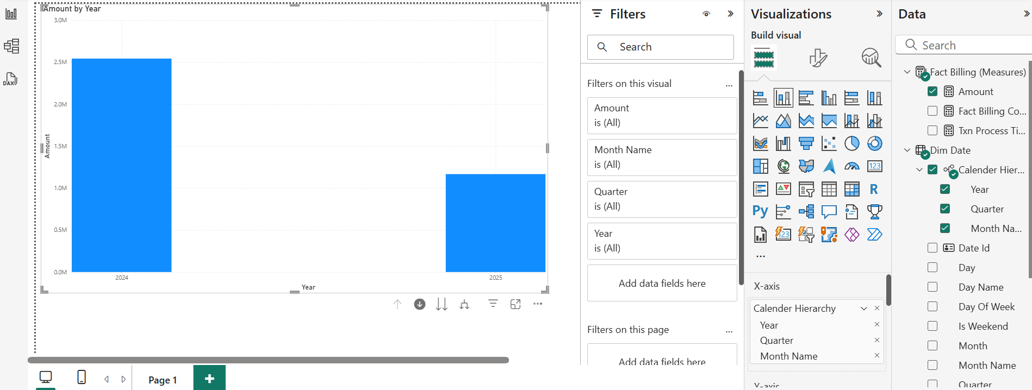  
  
Drill down enabled  
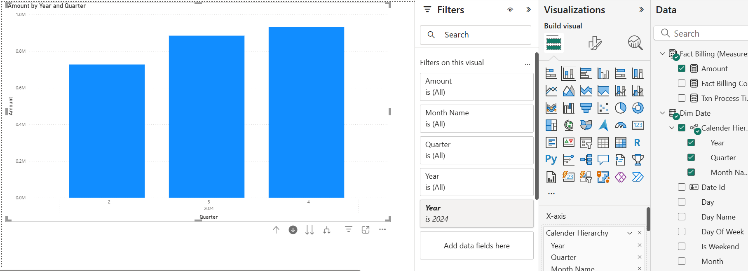  
  
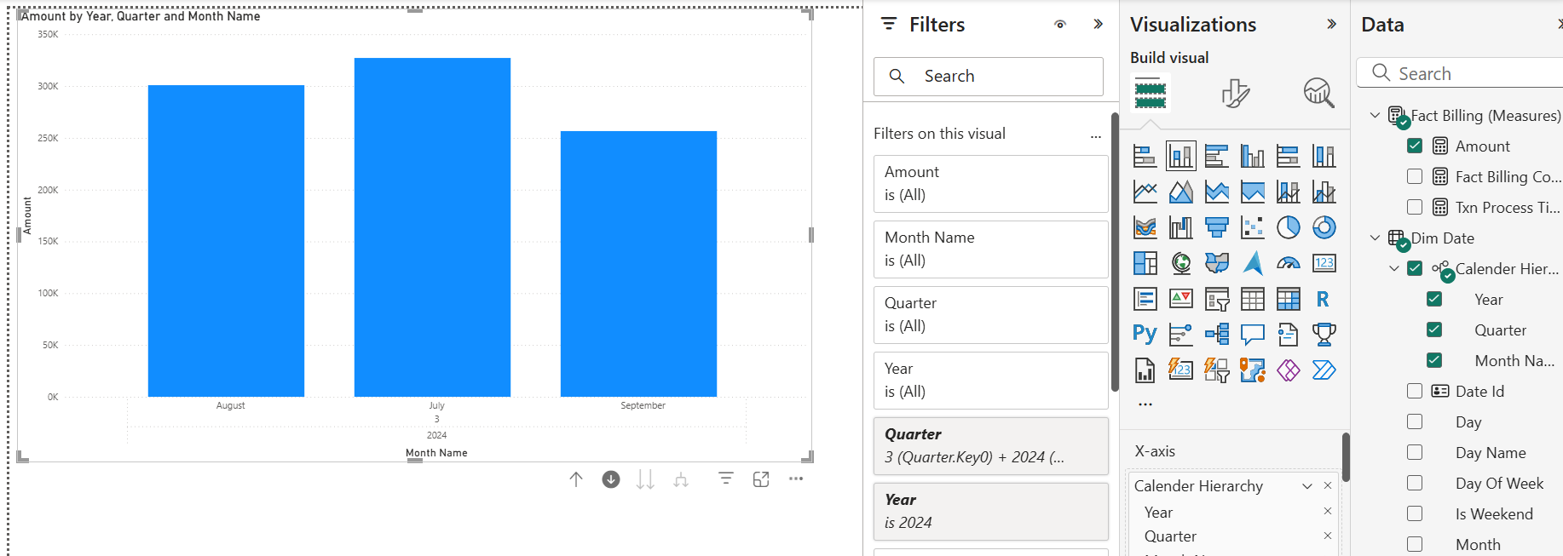  
  
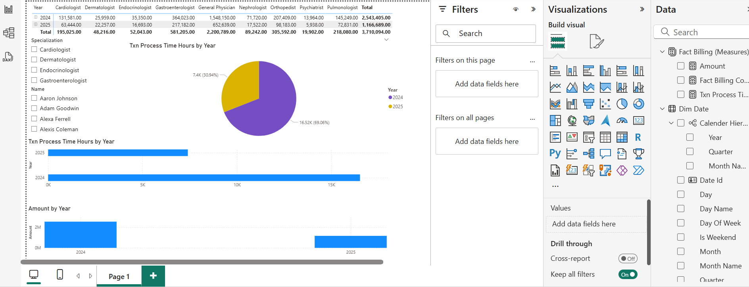  
  
Report 4  
  
Drill Through Report  
Doctor name and Amount Matrix  
  
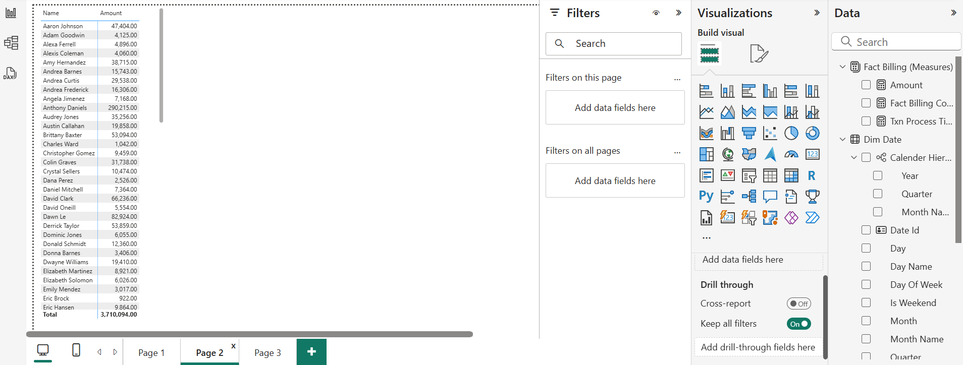  
  
Created a new page and added Drill-through via doctor name  
  
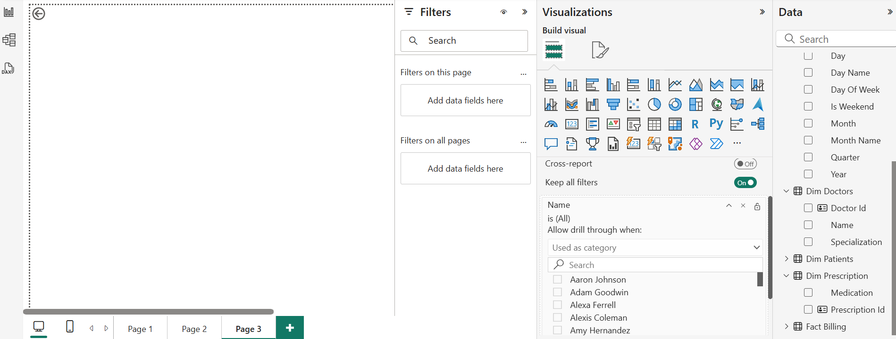  
  
Drill through considering Doctor name  
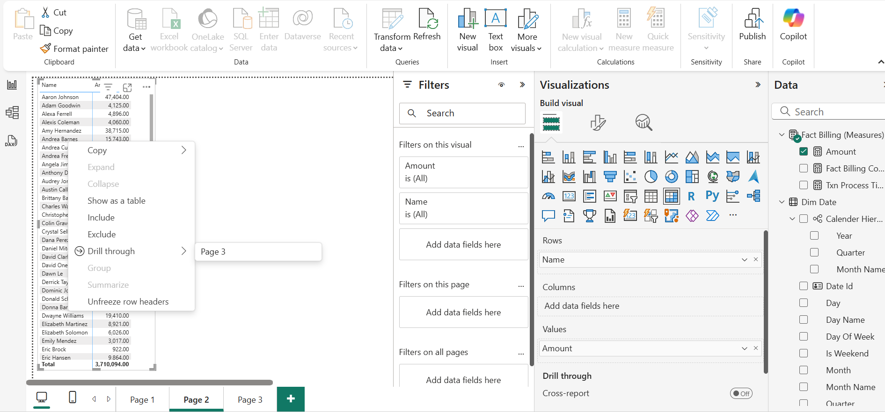  
  
Viewing Information  
  
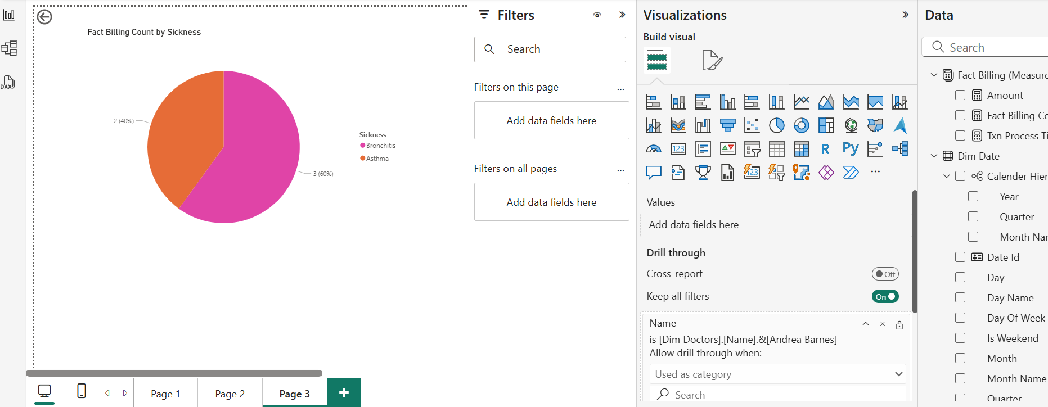

D

D

D